1. Write a Pandas program to select distinct department id from employees file.

+---------------+----------------------+------------+-------------+

| DEPARTMENT_ID | DEPARTMENT_NAME | MANAGER_ID | LOCATION_ID |

+---------------+----------------------+------------+-------------+

| 10 | Administration | 200 | 1700 |

| 20 | Marketing | 201 | 1800 |

| 30 | Purchasing | 114 | 1700 |

| 40 | Human Resources | 203 | 2400 |

| 50 | Shipping | 121 | 1500 |

| 60 | IT | 103 | 1400 |

| 70 | Public Relations | 204 | 2700 |

| 80 | Sales | 145 | 2500 |

| 90 | Executive | 100 | 1700 |

| 100 | Finance | 108 | 1700 |

| 110 | Accounting | 205 | 1700 |

| 120 | Treasury | 0 | 1700 |

| 130 | Corporate Tax | 0 | 1700 |

| 140 | Control And Credit | 0 | 1700 |

| 150 | Shareholder Services | 0 | 1700 |

| 160 | Benefits | 0 | 1700 |

| 170 | Manufacturing | 0 | 1700 |

| 180 | Construction | 0 | 1700 |

| 190 | Contracting | 0 | 1700 |

| 200 | Operations | 0 | 1700 |

| 210 | IT Support | 0 | 1700 |

| 220 | NOC | 0 | 1700 |

| 230 | IT Helpdesk | 0 | 1700 |

| 240 | Government Sales | 0 | 1700 |

| 250 | Retail Sales | 0 | 1700 |

| 260 | Recruiting | 0 | 1700 |

| 270 | Payroll | 0 | 1700 |

+---------------+----------------------+------------+-------------

SOLUTION:

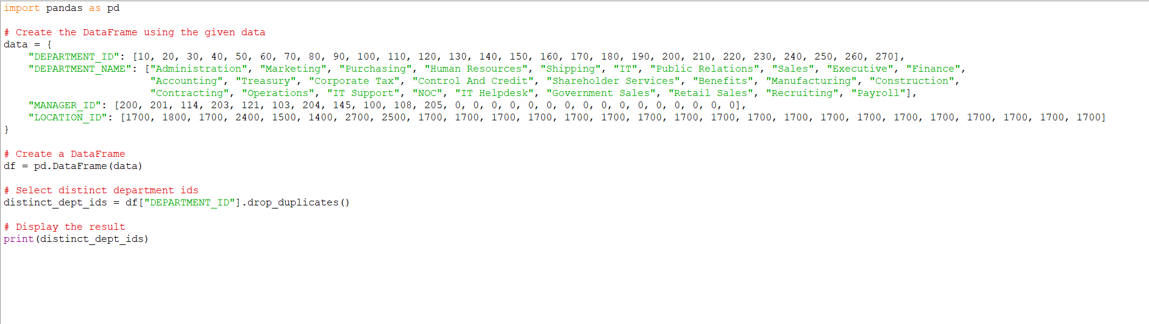

OUTPUT:

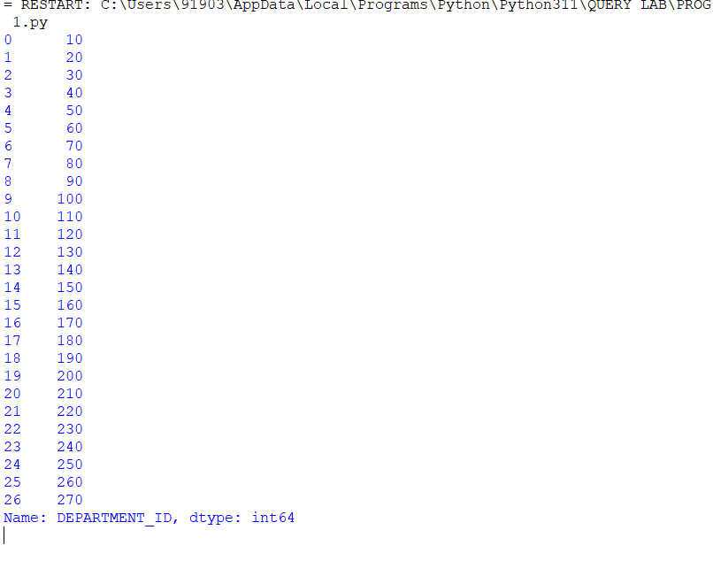

1. Write a Pandas program to display the ID for those employees who did two or more jobs in the past.

+-------------+------------+------------+------------+---------------+

| EMPLOYEE_ID | START_DATE | END_DATE | JOB_ID | DEPARTMENT_ID |

+-------------+------------+------------+------------+---------------+

| 102 | 2001-01-13 | 2006-07-24 | IT_PROG | 60 |

| 101 | 1997-09-21 | 2001-10-27 | AC_ACCOUNT | 110 |

| 101 | 2001-10-28 | 2005-03-15 | AC_MGR | 110 |

| 201 | 2004-02-17 | 2007-12-19 | MK_REP | 20 |

| 114 | 2006-03-24 | 2007-12-31 | ST_CLERK | 50 |

| 122 | 2007-01-01 | 2007-12-31 | ST_CLERK | 50 |

| 200 | 1995-09-17 | 2001-06-17 | AD_ASST | 90 |

| 176 | 2006-03-24 | 2006-12-31 | SA_REP | 80 |

| 176 | 2007-01-01 | 2007-12-31 | SA_MAN | 80 |

| 200 | 2002-07-01 | 2006-12-31 | AC_ACCOUNT | 90 |

+-------------+------------+------------+------------+---------------+

SOLUTION:

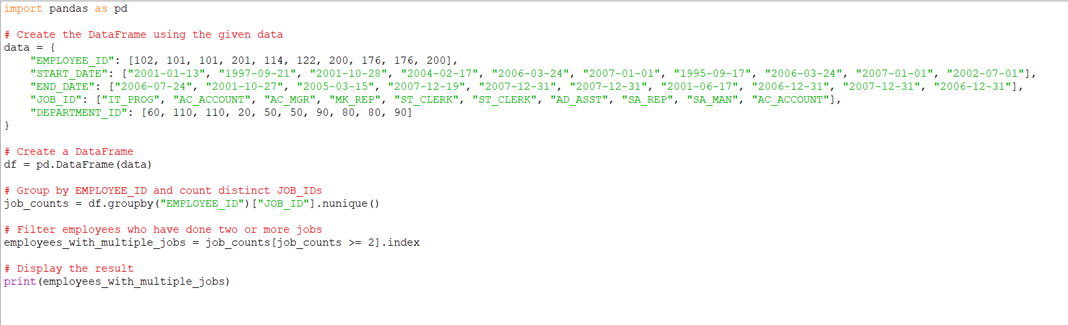

OUTPUT:



1. Write a Pandas program to display the details of jobs in descending sequence on job title.

+------------+---------------------------------+------------+------------+

| JOB_ID | JOB_TITLE | MIN_SALARY | MAX_SALARY |

+------------+---------------------------------+------------+------------+

| AD_PRES | President | 20080 | 40000 |

| AD_VP | Administration Vice President | 15000 | 30000 |

| AD_ASST | Administration Assistant | 3000 | 6000 |

| FI_MGR | Finance Manager | 8200 | 16000 |

| FI_ACCOUNT | Accountant | 4200 | 9000 |

| AC_MGR | Accounting Manager | 8200 | 16000 |

| AC_ACCOUNT | Public Accountant | 4200 | 9000 |

| SA_MAN | Sales Manager | 10000 | 20080 |

| SA_REP | Sales Representative | 6000 | 12008 |

| PU_MAN | Purchasing Manager | 8000 | 15000 |

| PU_CLERK | Purchasing Clerk | 2500 | 5500 |

| ST_MAN | Stock Manager | 5500 | 8500 |

| ST_CLERK | Stock Clerk | 2008 | 5000 |

| SH_CLERK | Shipping Clerk | 2500 | 5500 |

| IT_PROG | Programmer | 4000 | 10000 |

| MK_MAN | Marketing Manager | 9000 | 15000 |

| MK_REP | Marketing Representative | 4000 | 9000 |

| HR_REP | Human Resources Representative | 4000 | 9000 |

| PR_REP | Public Relations Representative | 4500 | 10500 |

+------------+---------------------------------+------------+------------+

SOLUTION:

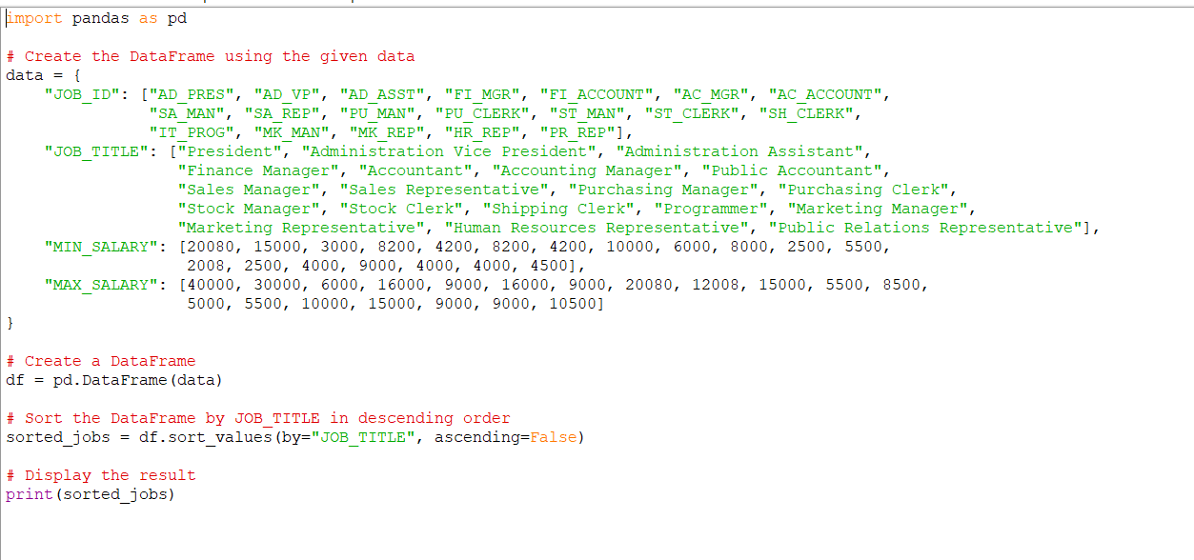

OUTPUT:

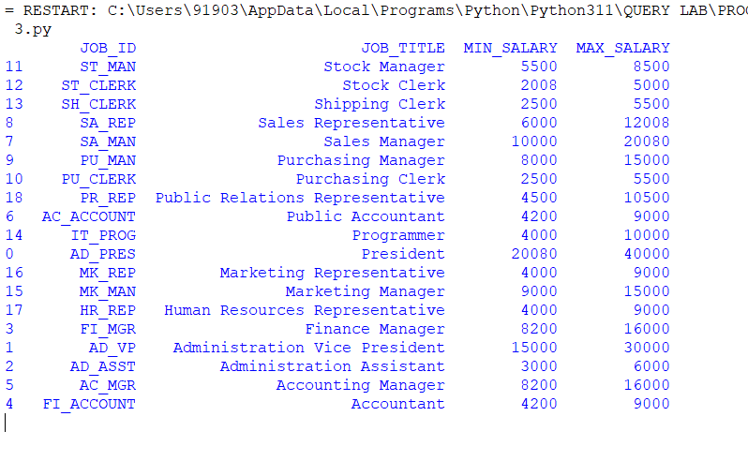

1. Write a Pandas program to create a line plot of the historical stock prices of Alphabet Inc. between two specific dates.

SOLUTION:

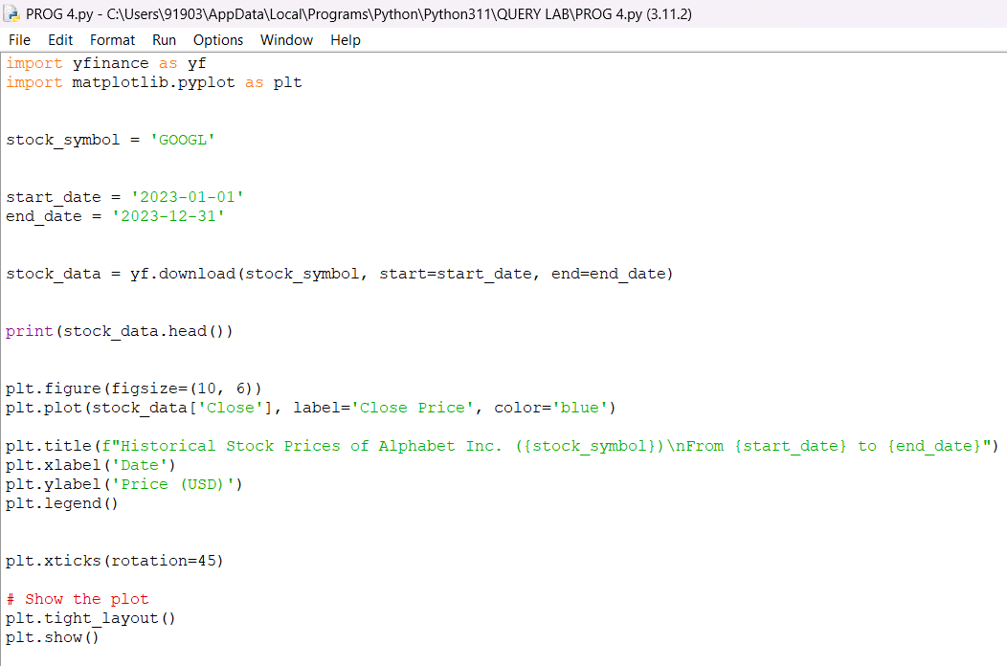

OUTPUT:

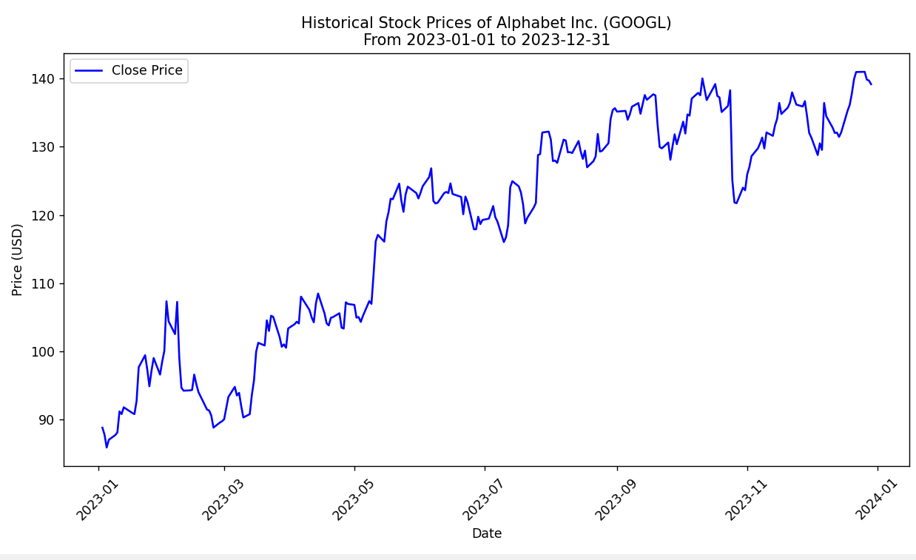

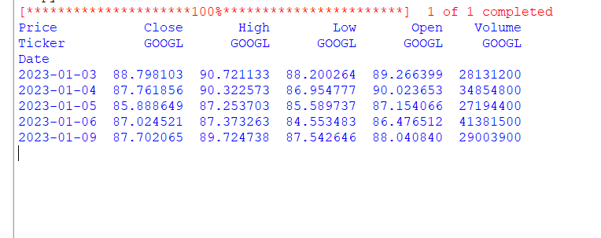

1. Write a Pandas program to create a bar plot of the trading volume of Alphabet Inc. stock between two specific dates.

SOLUTION:

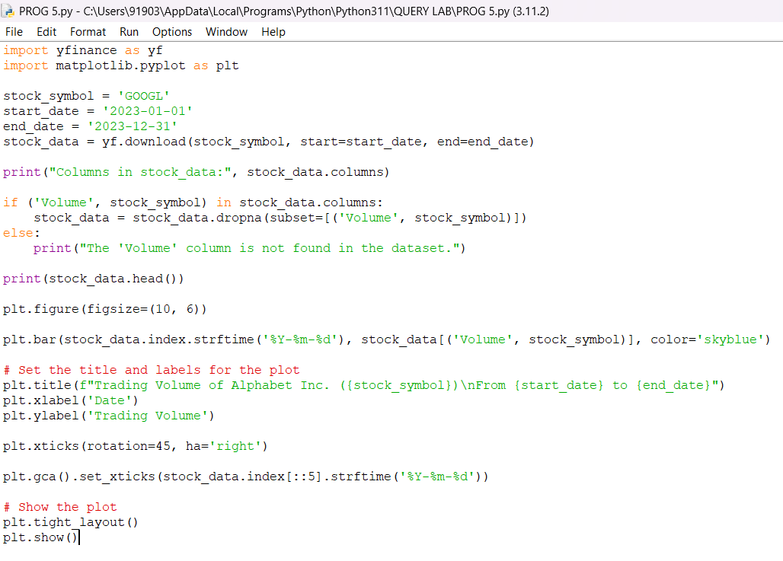

OUTPUT:

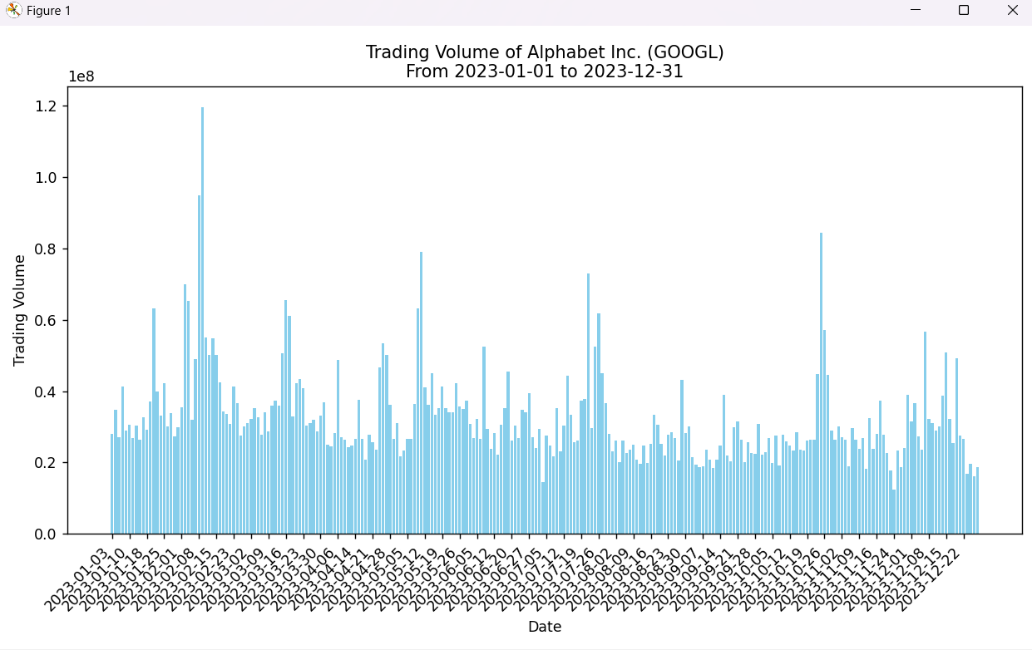

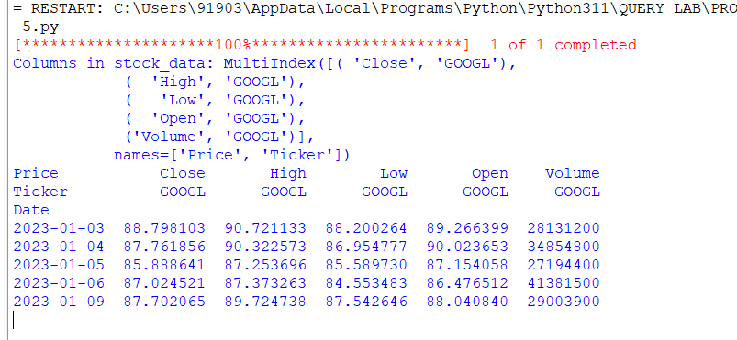

1. Write a Pandas program to create a scatter plot of the trading volume/stock prices of Alphabet Inc. stock between two specific dates.

**alphabet_stock_data:**

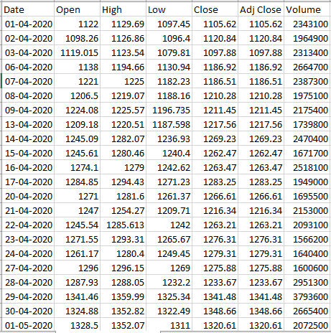

SOLUTION:

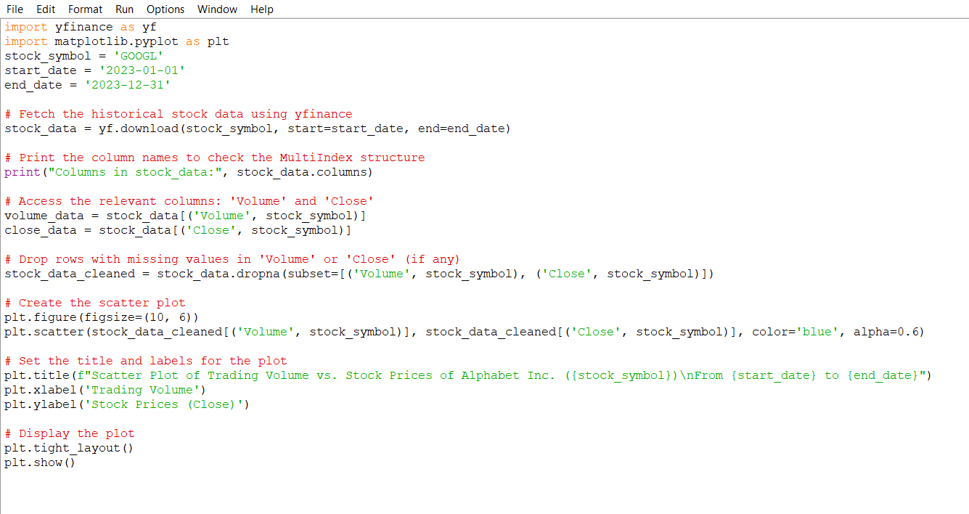

OUTPUT:

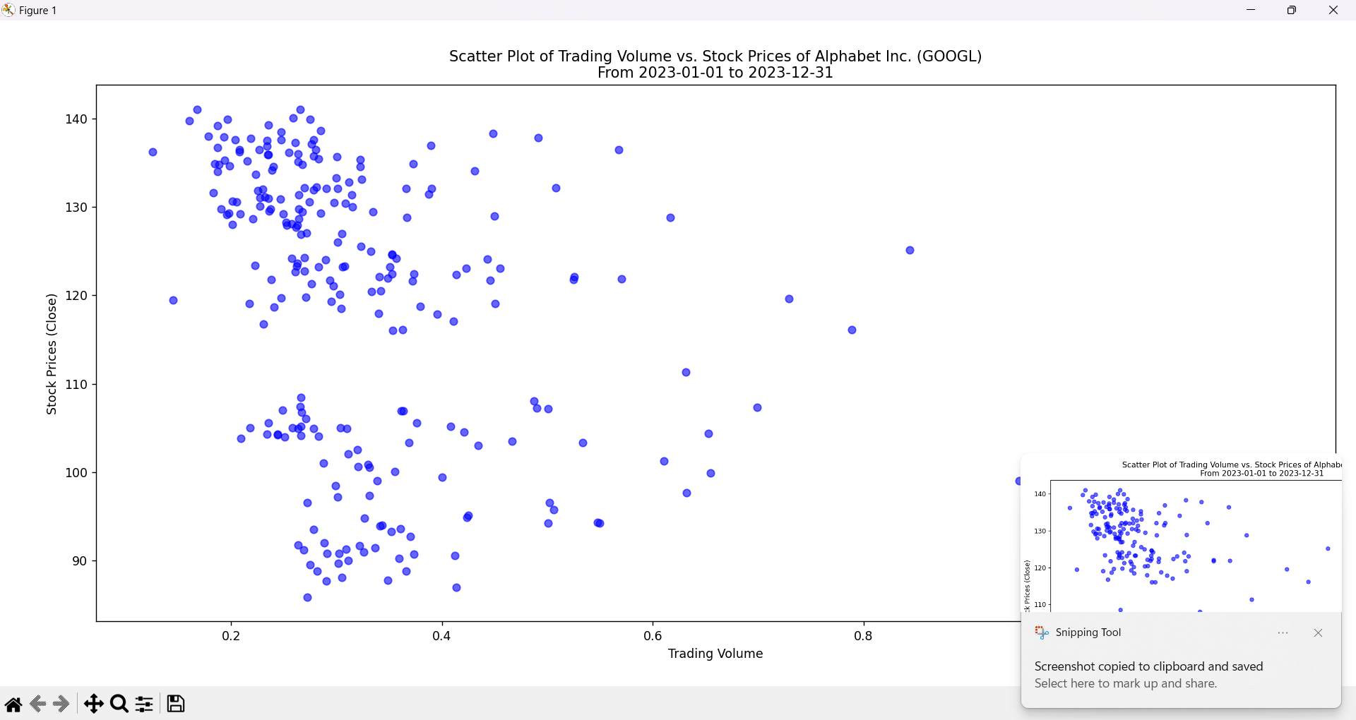

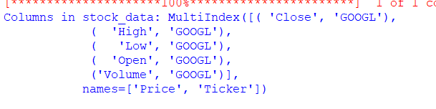

1. Write a Pandas program to create a Pivot table and find the maximum and minimum sale value of the items.(refer sales_data table)

SOLUTION:

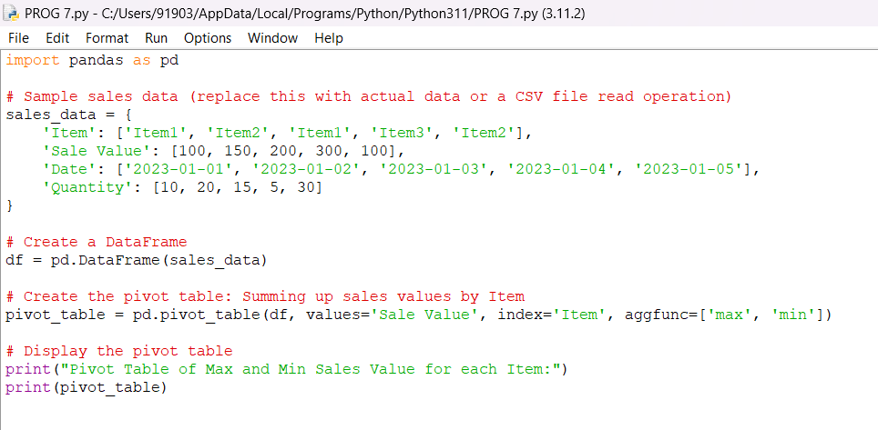

OUTPUT:

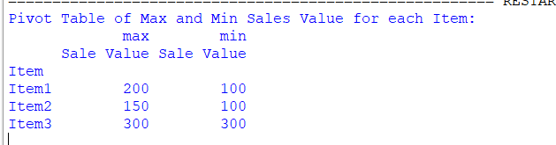

1. Write a Pandas program to create a Pivot table and find the item wise unit sold. .(refer sales_data table)

SOLUTION:

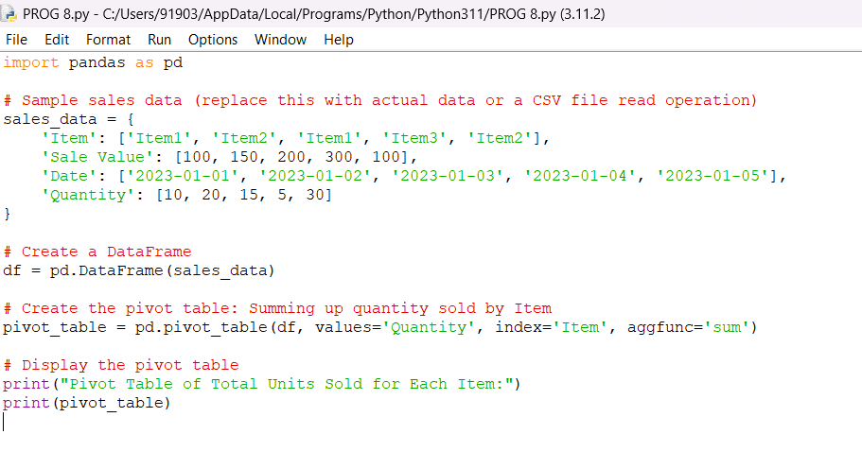

OUTPUT:

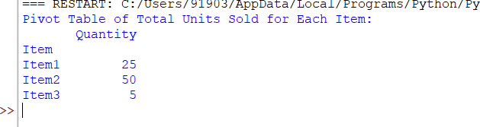

1. Write a Pandas program to create a Pivot table and find the total sale amount region wise, manager wise, sales man wise. .(refer sales_data table)

**Sales_data:**

|  |  |  |  |  |  |  |  |
| --- | --- | --- | --- | --- | --- | --- | --- |
| **OrderDate** | **Region** | **Manager** | **SalesMan** | **Item** | **Units** | **Unit_price** | **Sale_amt** |
| 1-6-18 | East | Martha | Alexander | Television | 95 | 1,198.00 | 1,13,810.00 |
| 1-23-18 | Central | Hermann | Shelli | Home Theater | 50 | 500.00 | 25,000.00 |
| 2-9-18 | Central | Hermann | Luis | Television | 36 | 1,198.00 | 43,128.00 |
| 2-26-18 | Central | Timothy | David | Cell Phone | 27 | 225.00 | 6,075.00 |
| 3-15-18 | West | Timothy | Stephen | Television | 56 | 1,198.00 | 67,088.00 |
| 4-1-18 | East | Martha | Alexander | Home Theater | 60 | 500.00 | 30,000.00 |
| 4-18-18 | Central | Martha | Steven | Television | 75 | 1,198.00 | 89,850.00 |
| 5-5-18 | Central | Hermann | Luis | Television | 90 | 1,198.00 | 1,07,820.00 |
| 5-22-18 | West | Douglas | Michael | Television | 32 | 1,198.00 | 38,336.00 |
| 6-8-18 | East | Martha | Alexander | Home Theater | 60 | 500.00 | 30,000.00 |
| 6-25-18 | Central | Hermann | Sigal | Television | 90 | 1,198.00 | 1,07,820.00 |
| 7-12-18 | East | Martha | Diana | Home Theater | 29 | 500.00 | 14,500.00 |
| 7-29-18 | East | Douglas | Karen | Home Theater | 81 | 500.00 | 40,500.00 |
| 8-15-18 | East | Martha | Alexander | Television | 35 | 1,198.00 | 41,930.00 |
| 9-1-18 | Central | Douglas | John | Desk | 2 | 125.00 | 250.00 |
| 9-18-18 | East | Martha | Alexander | Video Games | 16 | 58.50 | 936.00 |
| 10-5-18 | Central | Hermann | Sigal | Home Theater | 28 | 500.00 | 14,000.00 |
| 10-22-18 | East | Martha | Alexander | Cell Phone | 64 | 225.00 | 14,400.00 |

SOLUTION:

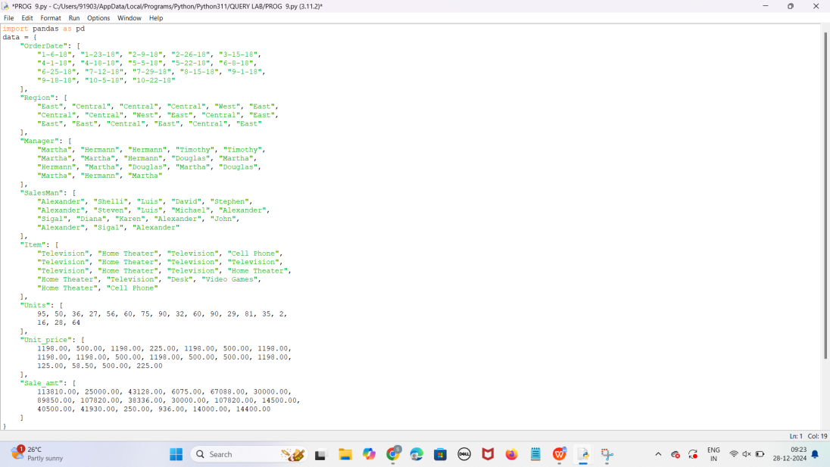

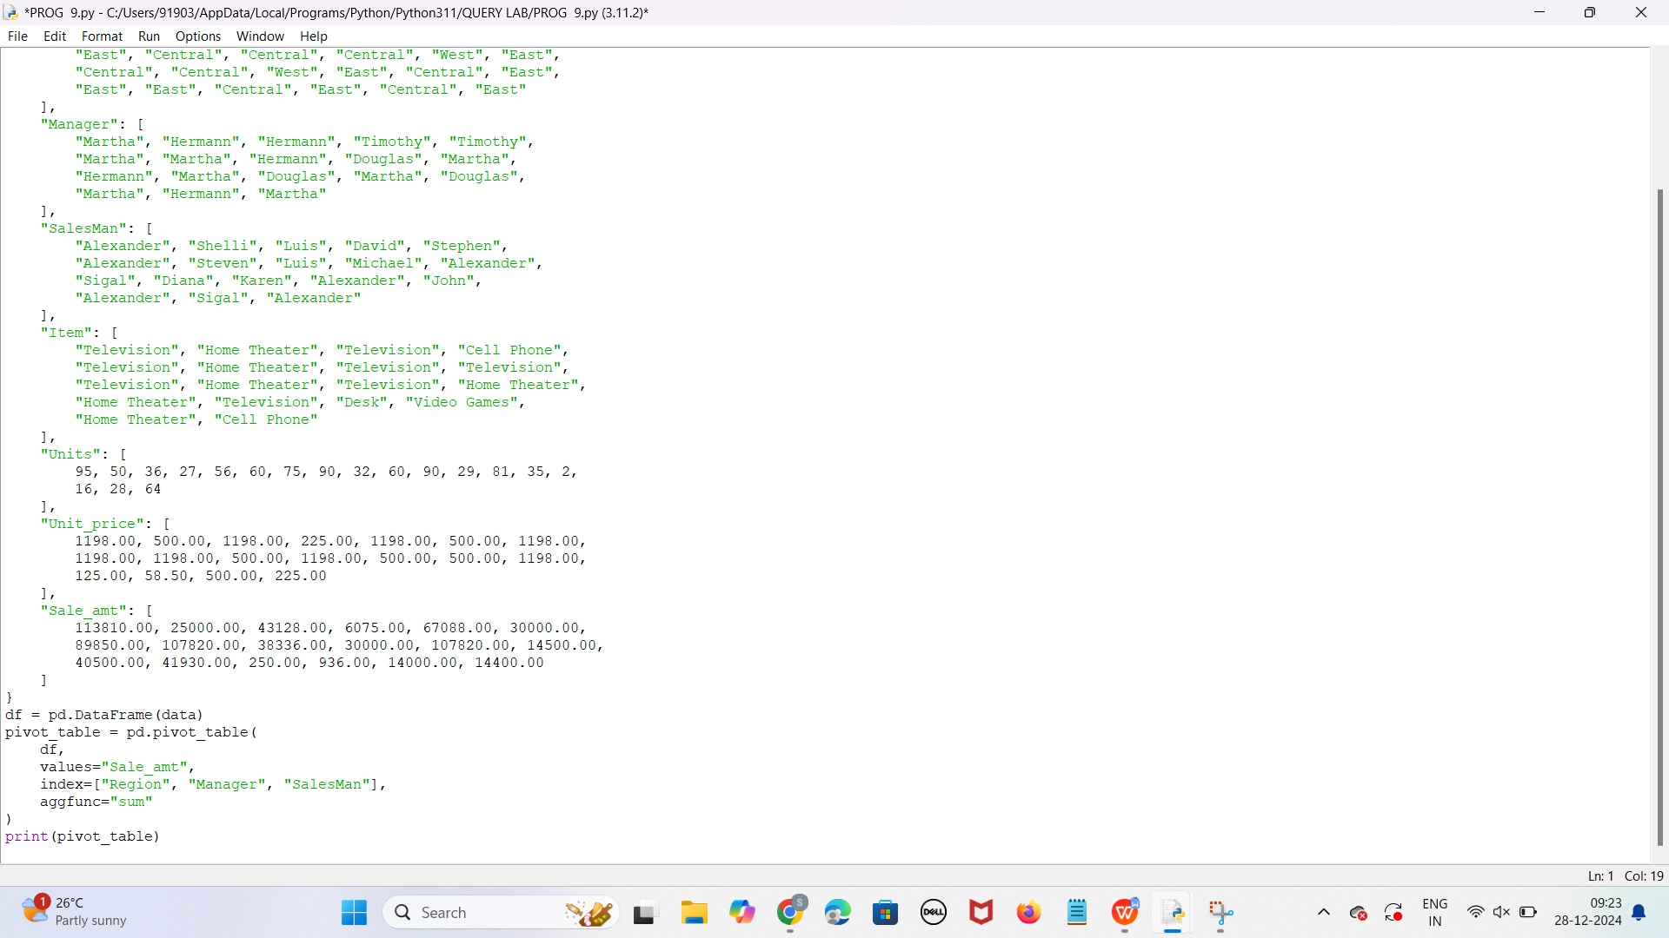

OUTPUT:

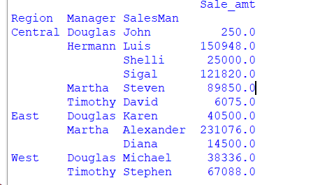

1. Create a dataframe of ten rows, four columns with random values. Write a Pandas program to highlight the negative numbers red and positive numbers black.

SOLUTION:

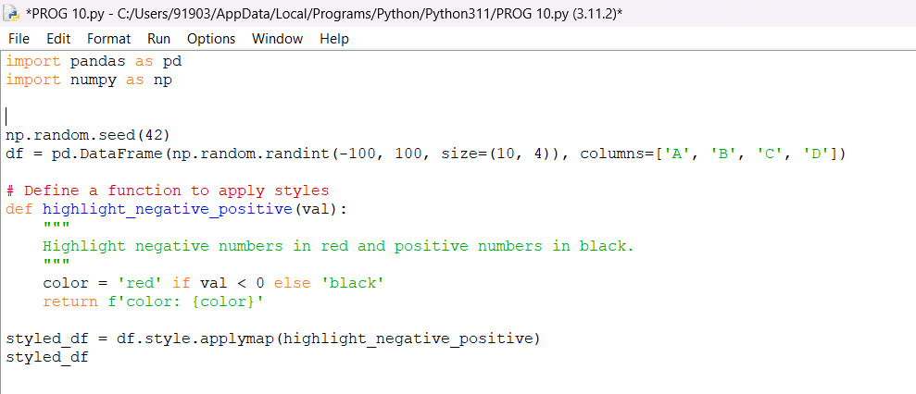

OUTPUT:

